DISASSEMBLY AND REPAIR
Product: SPIRA SWIVEL BASE

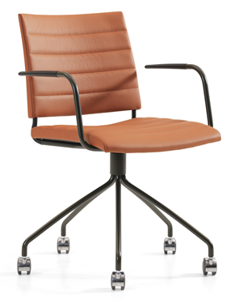

Replaceable parts | Tools needed
Seat | Screwdriver
Wheels | Wrench

Instructions for replacement
Seat Place the chair upside down and use a screwdriver to loosen the screws and remove the seat. Place the frame on top of the new seat. Important – Short screws for the flatbar in the back, and long screws in the front.
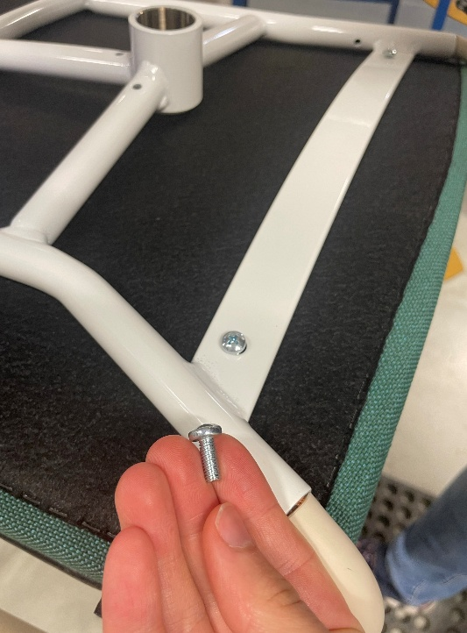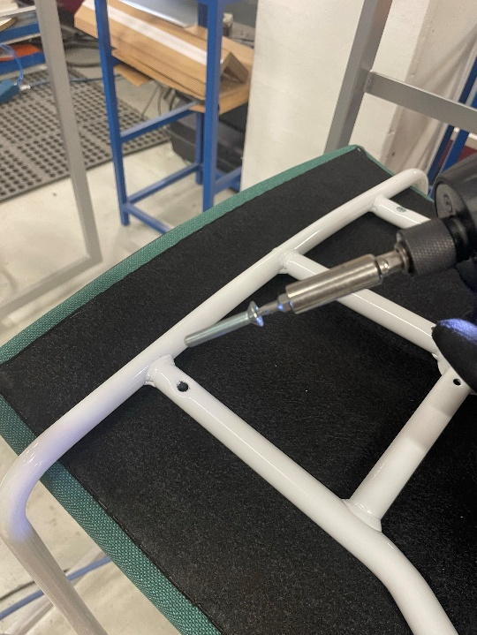
Wheels Use a wrench to remove the wheel. Insert the new one and tighten.

Disassembly for recycling
Place the chair upside down on a table and use a screwdriver to remove the seat. Ask a friend to hold the steel base with both hands while you strike the backrest with a rubber mallet a couple of times to remove the backrest. Use a wrench to remove the wheel. To remove the armrests, use a Ø5mm drill and drill out the pop rivets. Pull of the plastic part by hand.

