DISASSEMBLY AND REPAIR
Product: SPIRA

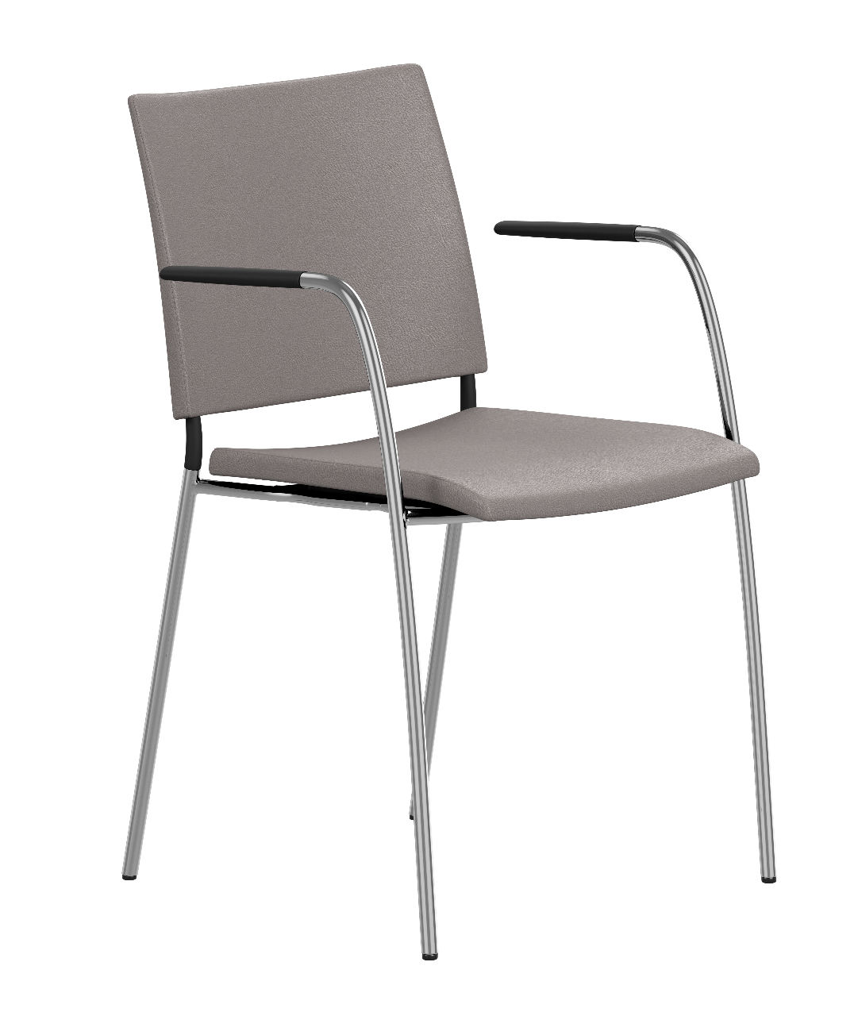

Replaceable parts | Tools needed
Glides | Adjustable pliers, rubber mallet
Seat | Screwdriver

Instructions for replacement
Glides Place the chair upside down on a table. Pull off the glide with adjustable pliers. Glides marked with 1 is for back legs and glides marked with 2 is for front legs. Insert the new glide, position it correct and strike it with a rubber mallet.
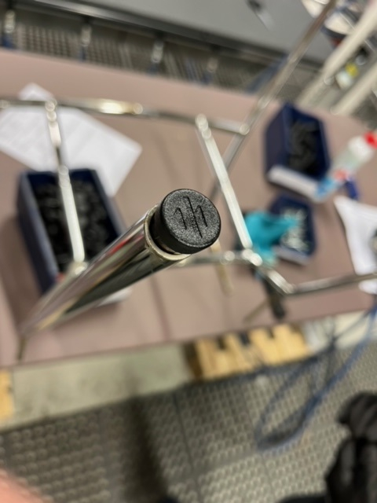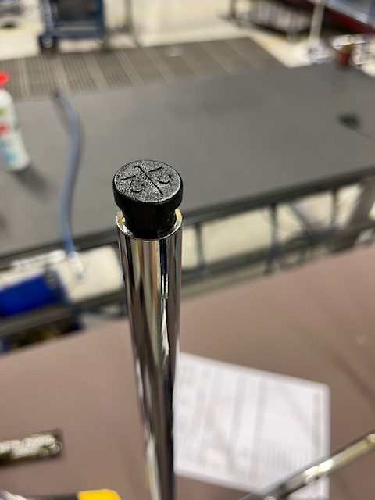

Seat (fabric) Place the chair upside down on a table and use a screwdriver to loosen the screws and remove the seat. Place the frame on top of the new seat, snap front of frame onto seat. Insert the screws again and tighten with a screwdriver.
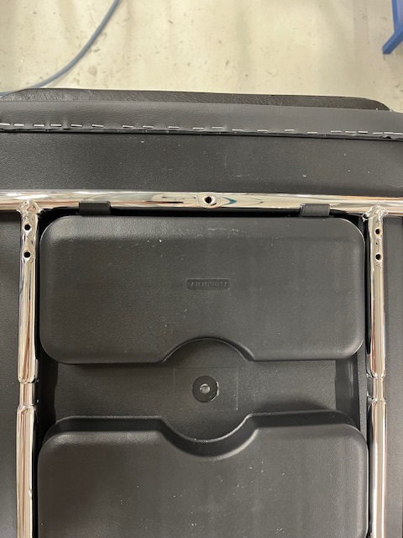

Disassembly for recycling
Place the chair upside down on a table and use a screwdriver to remove the seat. Ask a friend to hold the steel base with both hands while you strike the backrest with a rubber mallet a couple of times to remove the backrest. Pull off the glide with adjustable pliers. To remove the armrests, use a Ø5mm drill and drill out the pop rivets. Pull of the plastic part by hand.

