DISASSEMBLY AND REPAIR
Product: S70-3

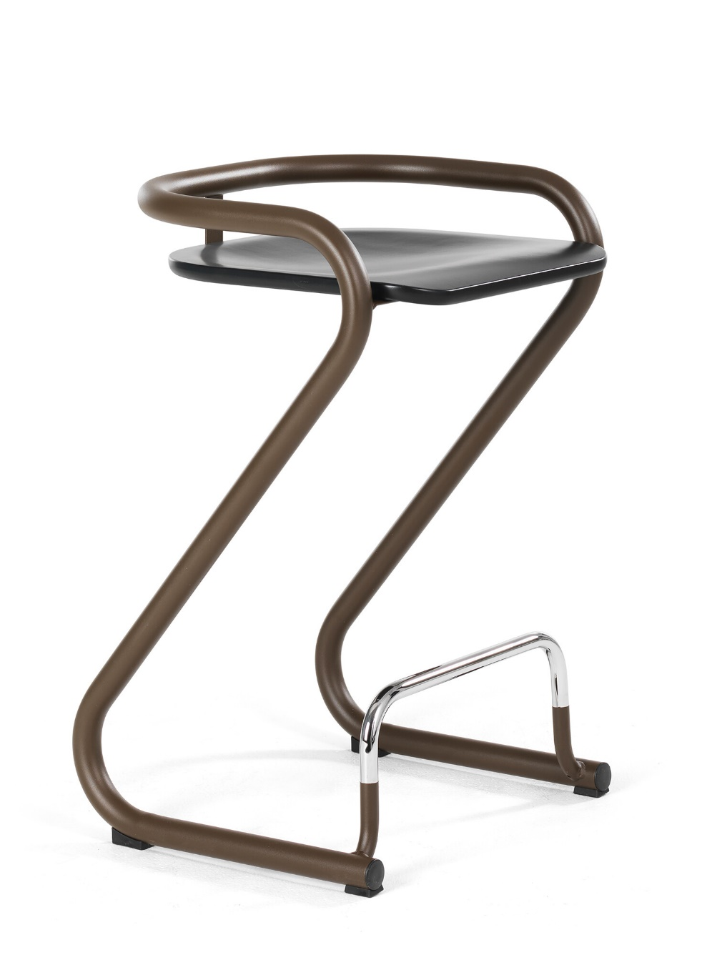

Replaceable parts | Tools needed
Seat | Screwdriver
Instructions for replacement
Seat Turn the stool upside down and measure the distance between the front of the seat and the flatbar (green dotted line). Remove the screws with a screwdriver and replace the seat. Center the seat to get the same gap between seat and the frame on both right and left side. Measure the distance at the front to get the same dimension as the old seat. Fasten it with the screws.
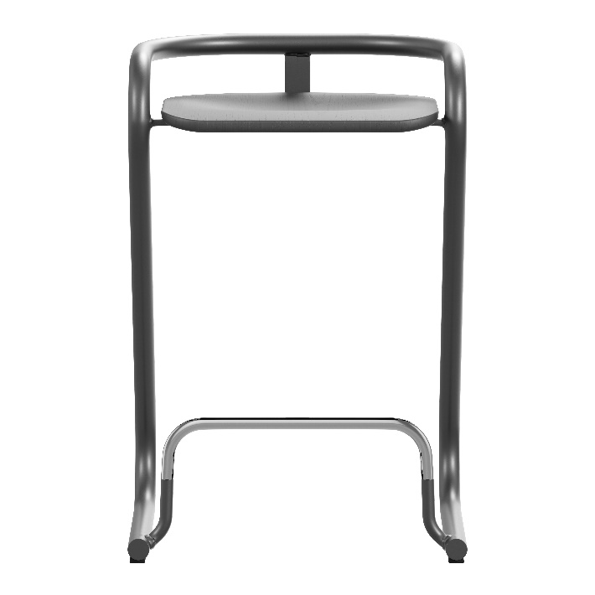

Disassembly for recycling
Remove all the screws underneath the seat with a screwdriver. To remove the plastic glides, use a Ø5mm drill and drill out the pop rivets.

