DISASSEMBLY AND REPAIR
Product: QUICKLY

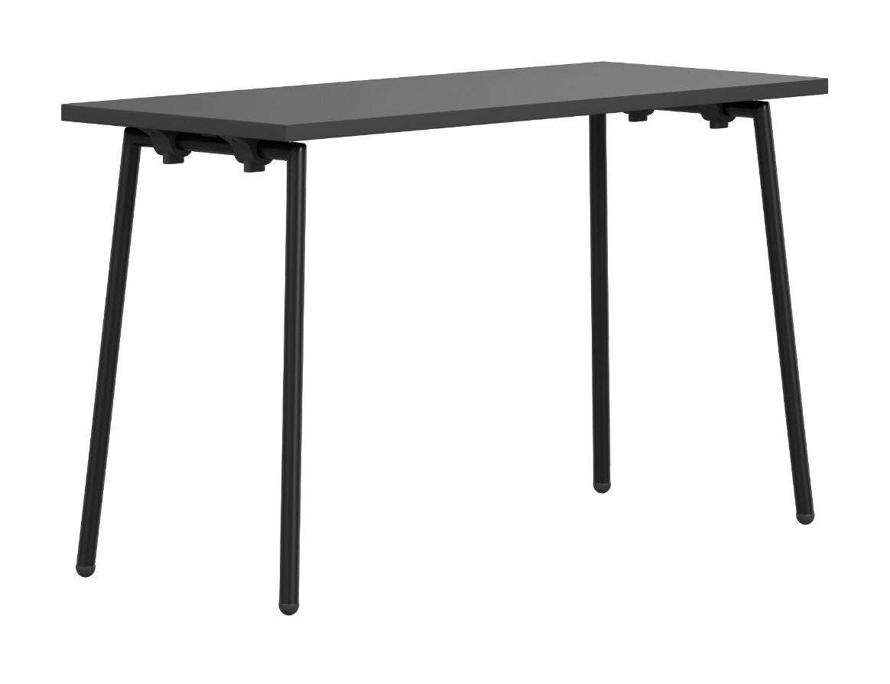

Replaceable parts | Tools needed
Glides | Adjustable pliers, rubber mallet
Legs | Screwdriver
Linking device | Screwdriver
Instructions for replacement

Leg Place the table upside down on the floor. Carefully loosen the screws in the plastic attachments with a screwdriver, keep track of which one is left and right. Detach the leg and move the plastic pieces onto the new leg. Place the new leg back in the fittings and make sure the little metal pin is pointing outwards.
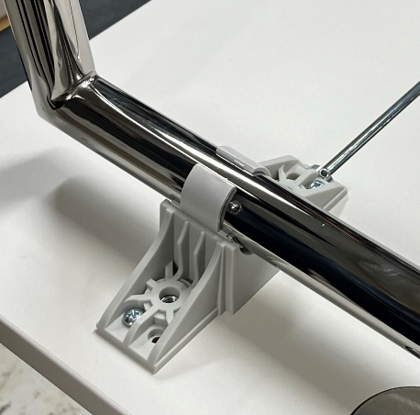
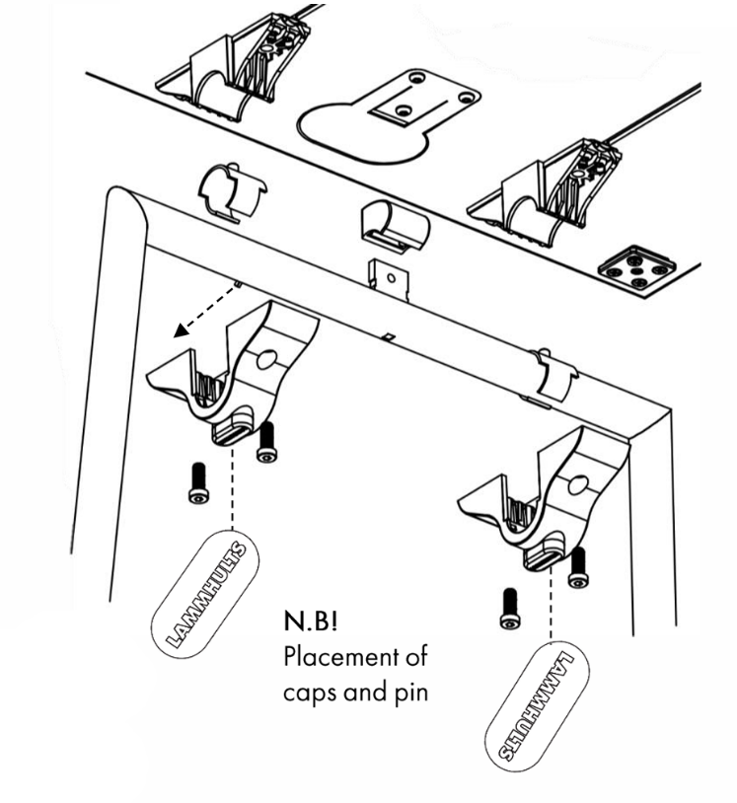
Place the plastic cover back in place, note the rotation of LAMMHULTS. Tighten the screws carefully, not to tight. Be careful when removing and fastening the screws.
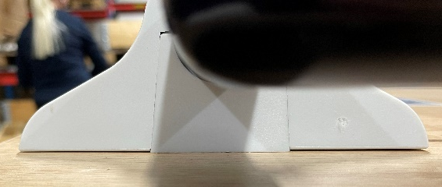
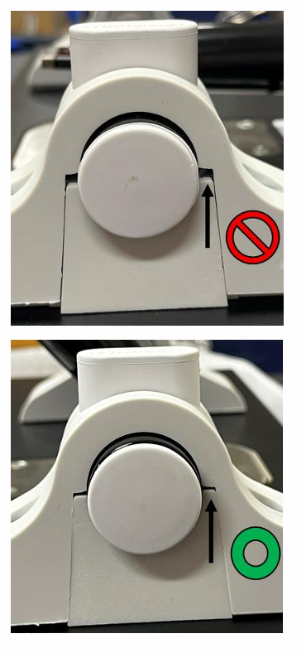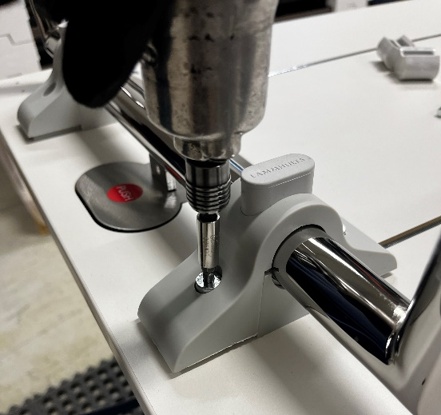
Next page >>>>
Move the pinch protection over from the old leg to the new one, use a rubber mallet.
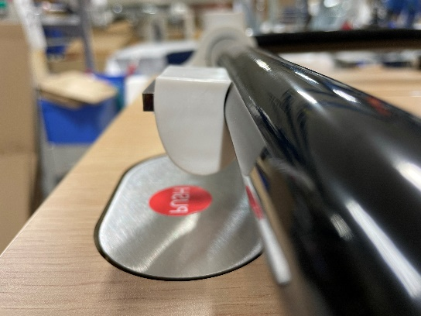
After assembly: make sure that the steel plates are locking the legs

Glides Remove the plastic part with your hand or adjustable pliers. Insert the new glide and press it down by hand or tap it into place with a rubber mallet.
Glide (T-leg) Remove the plastic part with your hand or adjustable pliers. Insert the new glide, make sure the rotation is correct, and press it down by hand or tap it into place with a rubber mallet.
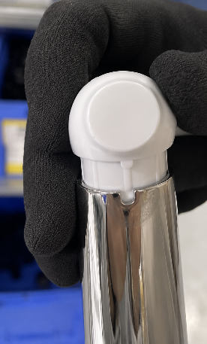
Linking device Carefully loosen the screws and replace the linking device.

Disassembly for recycling
Place the table upside down on the floor. Loosen all screws with a screwdriver. Remove the remaining plastic parts by hand or with adjustable pliers.

