DISASSEMBLY AND REPAIR
Product: GRADE SWIVEL

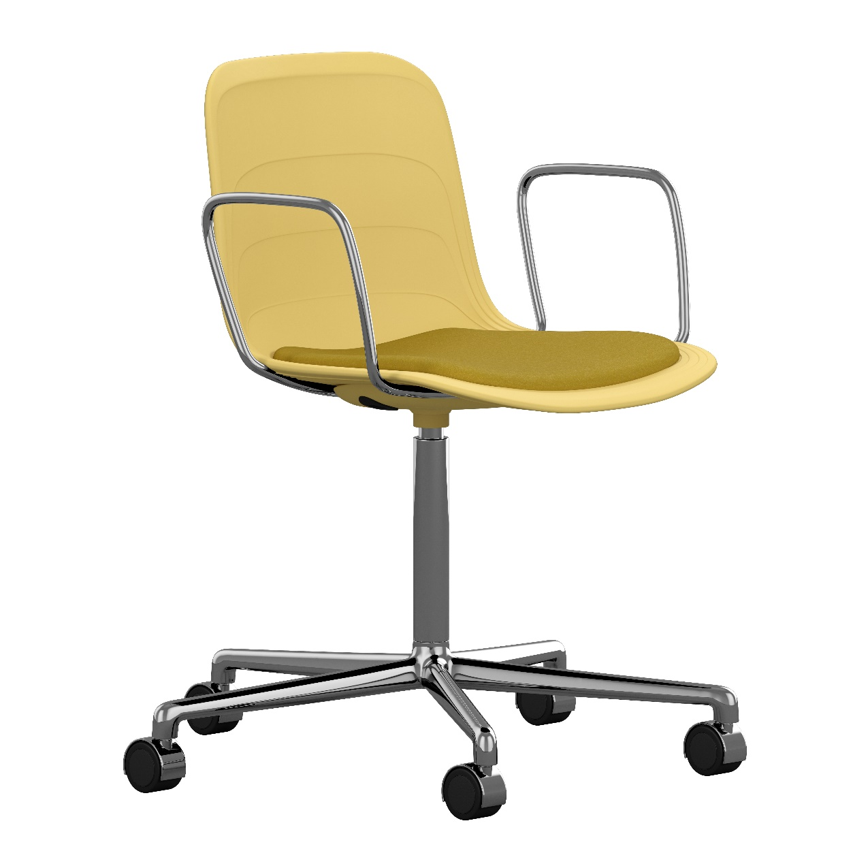

Replaceable parts | Tools needed
Armrests | Screwdriver
Glides | Adjustable pillars, rubber mallet
Seat shell | Screwdriver
Upholstered seat | Screwdriver
Wheels | -

Instructions for replacement
Armrests Tur the chair upside down. With low speed, loosen the screws in the seat attachment with a screwdriver. Lift the seat shell to the side and remove the screws holding the armrest. Put the new one in place and insert the screws again.
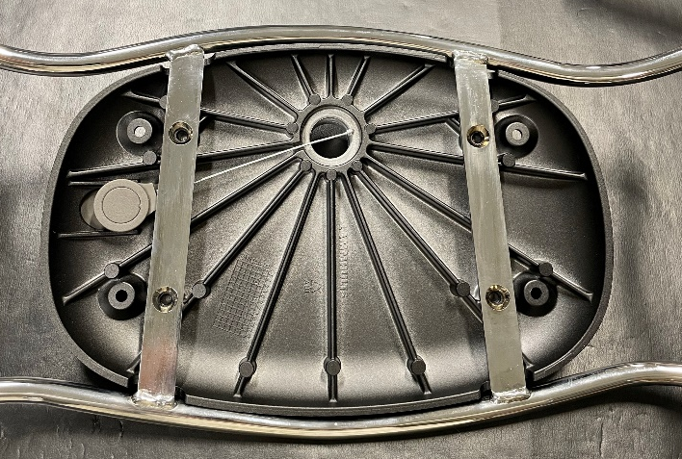
Place the seat shell back on top of the seat attachment. Put the washer onto the screw and apply a small amount of Loctite 480. Use low torque and tighten them slowly.
NOTE! Hand-tighten the final turns to ensure the screw is fully bottomed up.
Glides Remove the old glide with adjustable pliers, be careful with the powder coated base. Insert the new glide and press by hand or tap with a rubber mallet.
Seat shell Place the chair on the floor and remove the old screws. Put the washer onto the screw and apply a small amount of Loctite 480. Use low torque and tighten them slowly.
NOTE! Hand-tighten the final turns to ensure the screw is fully bottomed up.
Upholstered Tur the chair upside down and remove the four screws holding the seat, with a screwdriver. seat Remove the old seat pad and put the new one in place. Insert the screws and tighten.
Wheels Turn the chair upside down, place your hand around the wheel and pull. Insert the new wheel and press.

Disassembly for recycling
Loosen all screws with a screwdriver to remove the seat shell and armrests. Hold the base up and strike the starbase with a rubber mallet to separate the starbase from the pillar. Turn it upside down and strike the seat attachment to separate it from the pillar. Place your hand around one wheel at the time and pull to remove them, or use adjustable pillars to remove the glides.

