DISASSEMBLY AND REPAIR
Product: GRADE

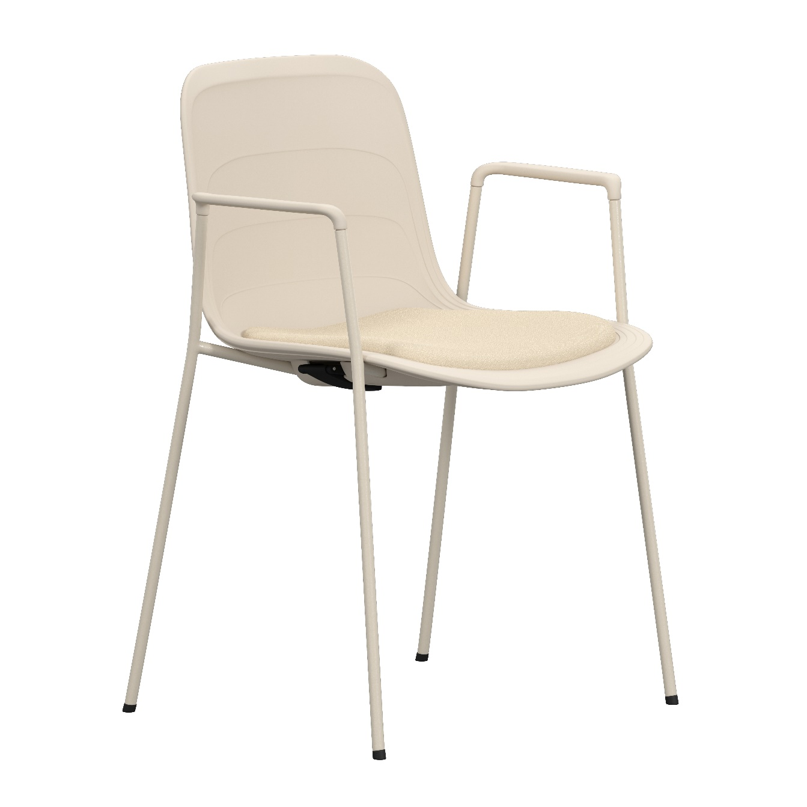
Replaceable parts | Tools needed
Armrests | Allen-key, rubber mallet
Glides | Adjustable pillars, rubber mallet
Seat shell | Screwdriver
Upholstered seat | Screwdriver
Instructions for replacement
Armrests Loosen the small set screws just below the plastic armrest with a allen-key. Pull by hand or tap with a rubber mallet to remove it. Insert the new armrest and tap gently with the rubber mallet to fit it in place. Secure it with set screws using the allen-key.
Note – The Armrest comes in a left and right version, make sure you place them correctly.
Glides Remove the old glide with adjustable pliers, be careful with the powder coated base. Insert the new glide, check the rotation, the marks should be facing inwards, against the glide on the same side (right side facing each other, left side facing each other). Tap them down with a rubber mallet.
Seat shell Place the chair on the floor and remove the screws in the seat attachment with a screwdriver. Remove the old shell (and, if present, also stacking pad). Put the base on to the new shell and top the base with the eventual stacking pad. Put the washer onto the screw and apply a small amount of Loctite 480. Use low torque and tighten them slowly.
NOTE! Hand-tighten the final turns to ensure the screw is fully bottomed up.
Upholstered Tur the chair upside down and remove the four screws holding the seat, with a screwdriver. seat Remove the old seat pad and put the new one in place. Insert the screws and tighten.

Disassembly for recycling
Loosen all screws with a screwdriver to remove the seat shell and seat pad. Loosen the screws holding the armrests and strike with the rubber mallet to remove them. Use adjustable pillars to remove the glides.

