DISASSEMBLY AND REPAIR
Product: CAROUSEL

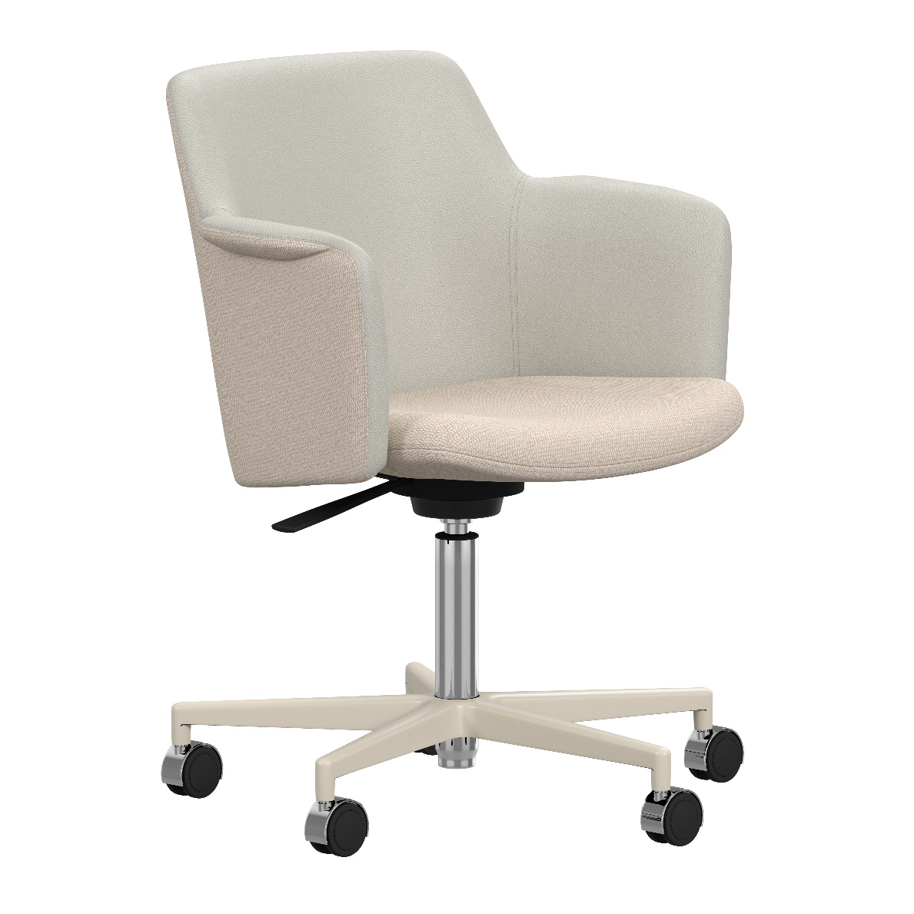
Replaceable parts | Tools needed
Backrest | Screwdriver
Glides | -
Rubber tilt | Screwdriver, rubber mallet
Seat | Screwdriver
Starbase | Rubber mallet
Swivel base | Screwdriver
Swivel column | Rubber mallet
Wheels | -
Instructions for replacement
Backrest Ask a friend for assistance. Lay the chair on the floor and use a power drill to loosen the screws in the black steel brackets on the underside of the seat. Remove the old backrest and place the new one in the same position. Use the same screws to fasten the new backrest.
Glides Pull off the glide by hand. Press on the new glide or wheel.
Rubber tilt Ask a friend for assistance. Hold the chair upside down, place one hand around the pillar and ask your friend to hold the backrest. Use a rubber mallet to strike the underside of the seat attachment to separate the column from the seat attachment. Unscrew the screws to remove the seat attachment. Replace the rubber part and tighten the screws again. Place the swivel base on the floor in upright position and place the seat shell on top. Sit down to press it in place.
Seat Ask a friend for assistance. Lay the chair on the floor and use a power drill to loosen the four screws in the seat attachment. Also loosen the screws in the black steel brackets on the underside of the seat to remove the backrest. Assemble the new seat with the backrest - Press the seat down against the backrest and tighten the screws in the centered bracket first. Then tighten the screws on the left and right side. Turn the seat shell upside down, place the swivel base back and tighten the screws. Make sure the handle (for height adjustment) is rotated in the correct position.
Starbase Ask a friend for assistance. Place your hand around the pillar and hold up the chair with one arm, use a rubber mallet and strike the starbase. Pull off the glides or wheels by hand and mount them on the new starbase. Put the starbase on the floor and place the seatshell with column back in place. Sit down to press it in place.
Swivel base Lay the chair on the floor and use a power drill to loosen the four screws in the seat attachment. Remove the old swivel base and put the new one in place. Tighten the screws. Make sure the handle (for height adjustment) is rotated in the correct position
Swivel column Ask a friend for assistance. Place your hand around the pillar and hold up the chair with one arm, use a rubber mallet and strike the starbase. When the starbase is removed, turn the chair uside down and strike the seat attachment to separate the swivel column. Put the starbase on the floor and place the new column in the center. Place the seat on top of the column and press down. Sit down for extra press.
Wheels Pull off the wheel by hand. Press on the new wheel or glide.

Disassembly for recycling
Lay the chair on the floor and use a power drill to loosen all the screws underneath the seat. Hold the pillar in one hand and use a rubber mallet and strike the starbase to separate it from the pillar. Pull off the glides or wheels by hand.

