DISASSEMBLY AND REPAIR
Product: CAROUSEL 4-LEGS

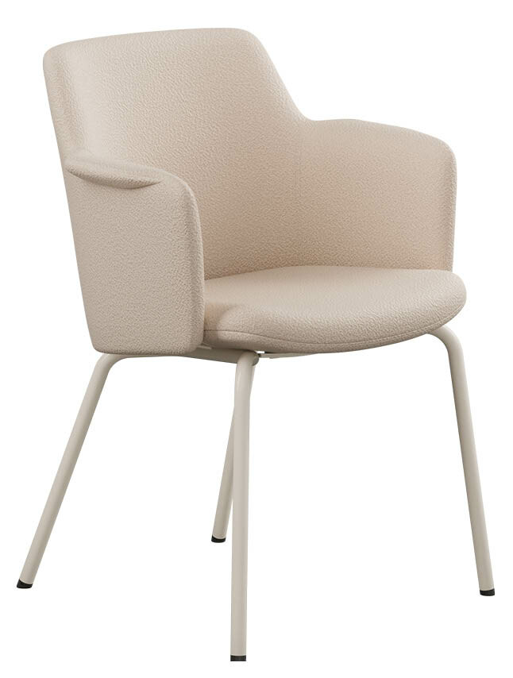
Replaceable parts | Tools needed
Backrest | Screwdriver
Dampers | Screwdriver
Glides | Manual screwdriver
Seat | Screwdriver
Steel base | Rubber mallet

Instructions for replacement
Backrest Ask a friend for assistance. Lay the chair on the floor and use a power drill to loosen the screws in the black steel brackets on the underside of the seat. Remove the old backrest and place the new one in the same position. Use the same screws to fasten the new backrest.
Dampers Place the chair on the floor and use a power drill to loosen the four screws holding the base, underneath the seat. Remove the damaged damper by hand and insert the new one, tighten by hand. Place the steel base on top of the dampers, insert and tighten the four screws.
Glides Use a screwdriver to pop off the foot part. Click on the new one.
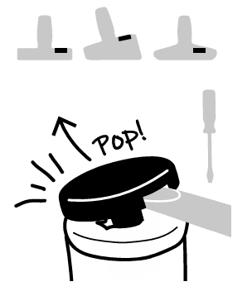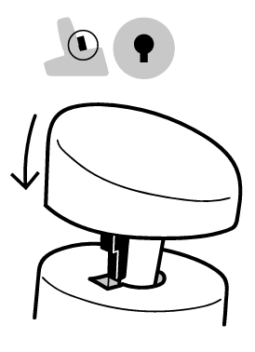
Seat Place the chair on the floor and use a power drill to loosen the four screws holding the base, underneath the seat. Remove the dampers by hand. Also loosen the screws in the black steel brackets on the underside of the seat to remove the backrest. Assemble the new seat with the backrest - Press the seat down against the backrest and tighten the screws in the centered bracket first. Then tighten the screws on the left and right side. Turn the seat shell upside down and screw the dampers back in place. Place the steel base on top of the dampers, insert and tighten the four screws.
Steel base Lay the chair on the floor and use a power drill to loosen the four screws holding the base, underneath the seat. Remove the old base and put the new one in place. Tighten the screws.

Disassembly for recycling
Lay the chair on the floor and use a power drill to loosen all the screws underneath the seat. Remove the dampers by hand and remove glides using adjustable pliers.

