DISASSEMBLY AND REPAIR
Product: CAMPUS BARSTOOL

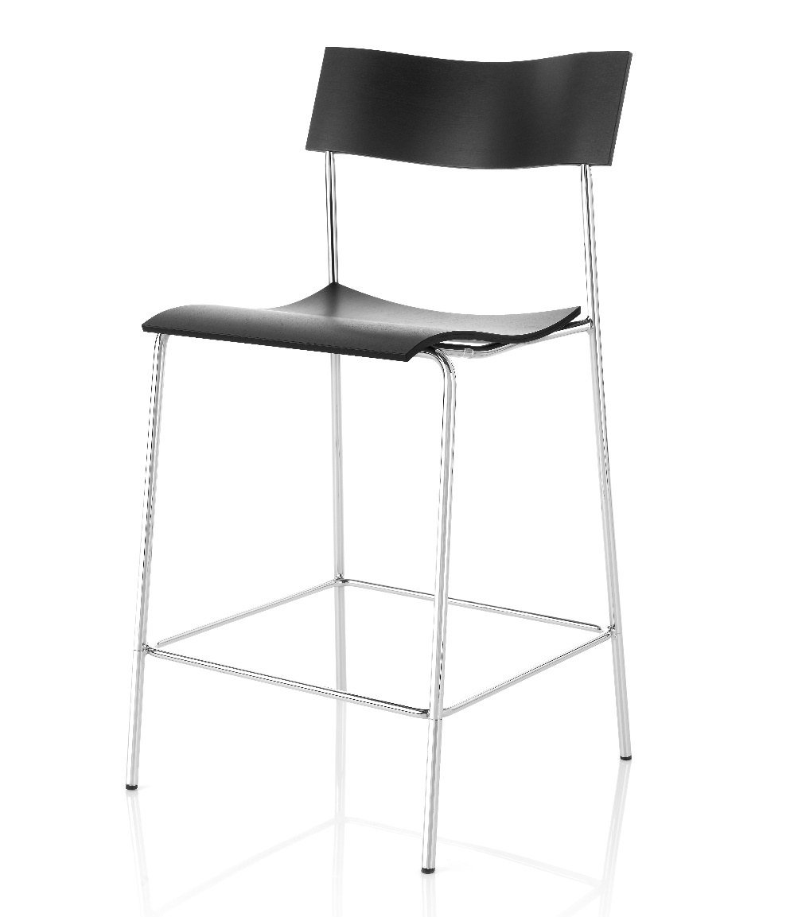

Replaceable parts | Tools needed
Glides | Adjustable pliers, rubber mallet
Seat | Screwdriver

Instructions for replacement
Glides Pull off the glide with adjustable pliers. Insert the new glide, position it correct and strike it with a rubber mallet.
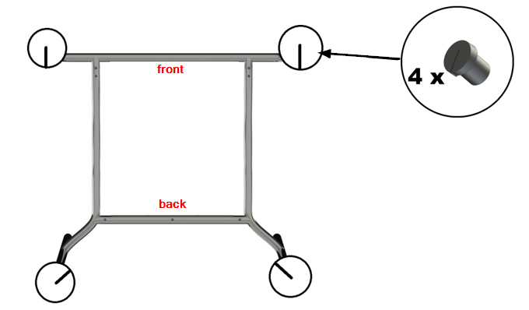

Seat Place the chair upside down on a table and use a screwdriver to remove the screws, 3 in the front and 2 in the back. Remove the old seat and replace it with the new one. Place the plastic distances, one for each hole. Gently place the base on top without dislocating them. Use a screwdriver to fasten the screws, 5 pcs of MF6S 5x22.
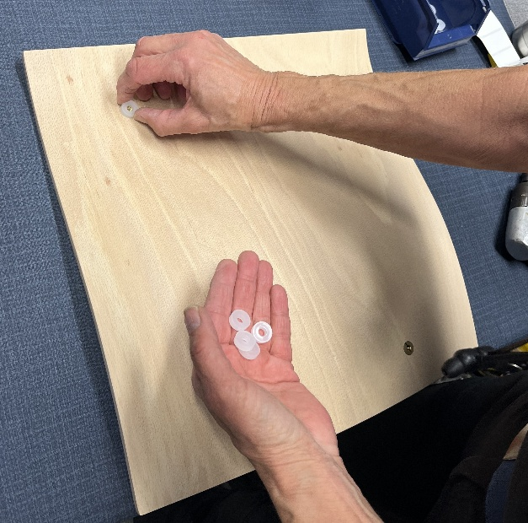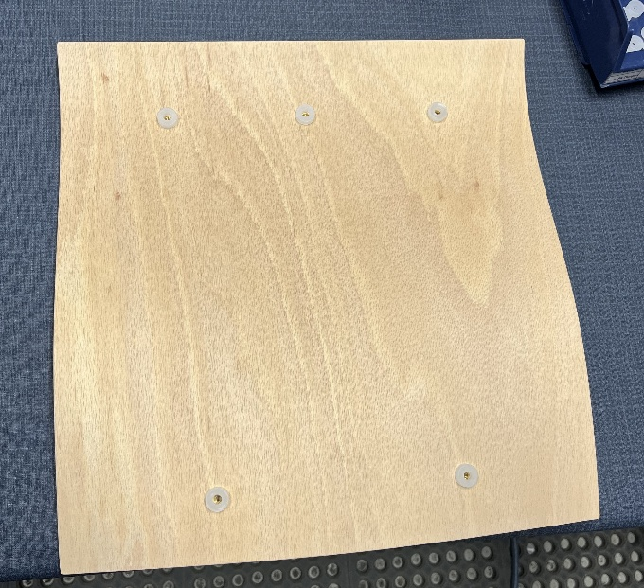

Disassembly for recycling
Place the chair down on the floor and use a screwdriver to remove the seat. To remove the backrest, saw the back in half down the middle and twist the parts to detach them from the frame. Pull off the glide with adjustable pliers.

