DISASSEMBLY AND REPAIR
Product: CAMPUS AIR

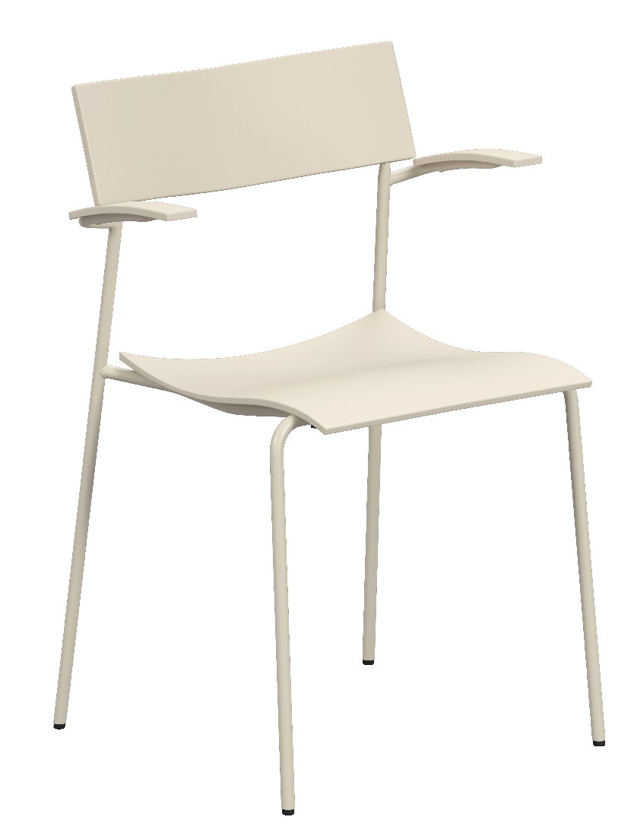

Replaceable parts | Tools needed
Glides | Adjustable pliers, rubber mallet
Seat | Screwdriver

Instructions for replacement
Glides Pull off the glide with adjustable pliers. Insert the new glide, position it correct and strike it with a rubber mallet.
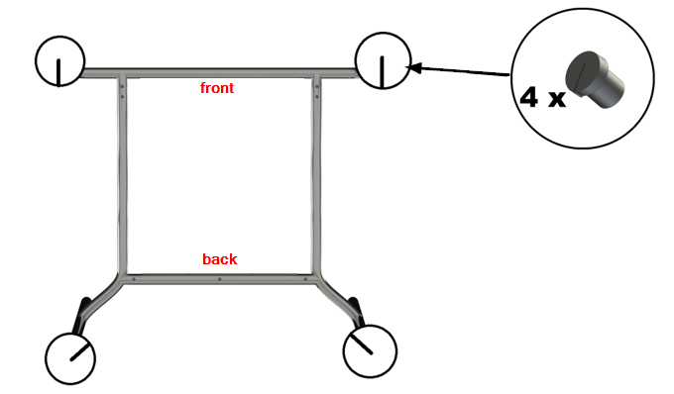
Seat Place the chair upside down on a table and use a screwdriver to remove the screws, 3 in the front and 2 in the back. Remove the old seat and replace it with the new one. Make sure the new seat has all bumpers in place.
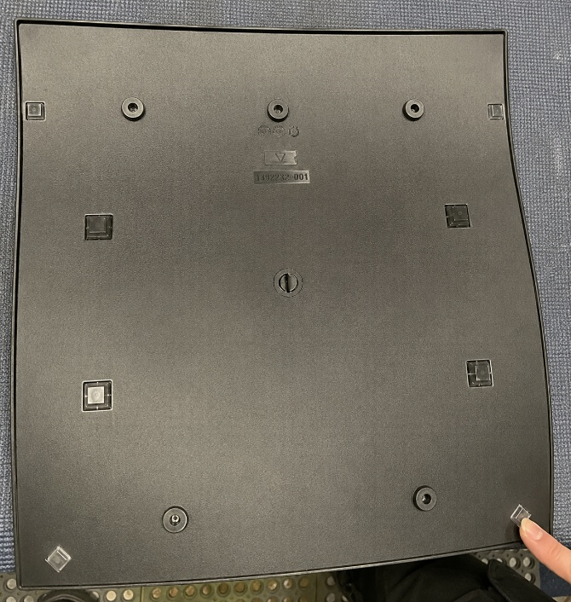

Start by tighten the screw placed in the middle front hole, to make sure that the frame is in position. Continue with the remaining screws.

Disassembly for recycling
Place the chair upside down on a table and use a screwdriver to remove the seat and stacking bumpers. To remove the backrest, saw the back in half down the middle and twist the parts to detach them from the frame. Pull off the glide with adjustable pliers. To remove the armrests, use a screwdriver to loosen the screws and strike the armrest with a rubber mallet to separate it from the frame.

