DISASSEMBLY AND REPAIR
Product: BAU

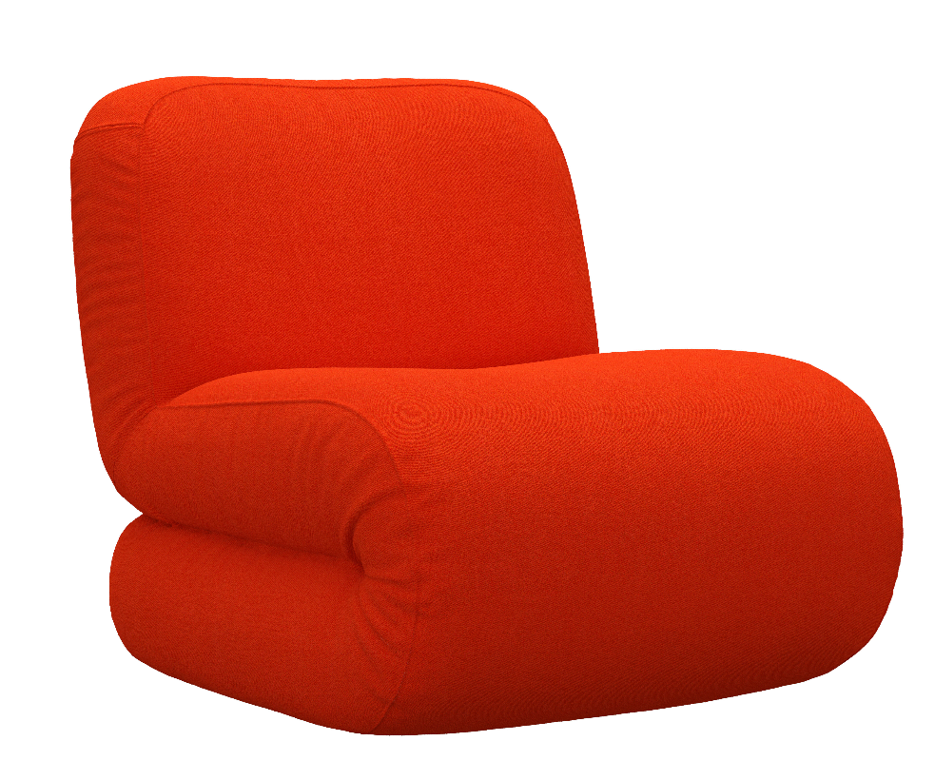

Replaceable parts | Tools needed
Base | Screwdriver
Glides | -
Swivel base | Screwdriver

Instructions for replacement
Base Loosen the screws with a screwdriver.
Glides Turn the easy chair upside down and use your hand to unscrew the glide. Mount the new one.
Swivel base Loosen the screws with a screwdriver.
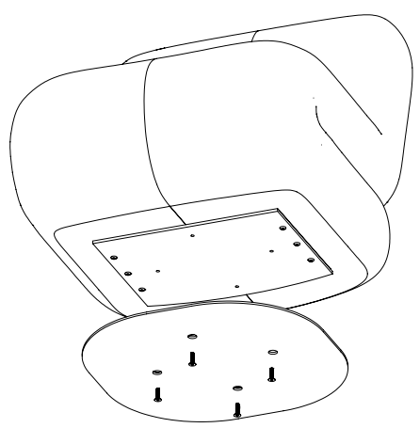

Disassembly for recycling
Turn Bau upside down and unscrew the glides or base with a screwdriver. If the easy chair has swivel base, use a screwdriver to remove it. Use a knife to remove the fabric.

