DISASSEMBLY AND REPAIR
Product: ATTACH

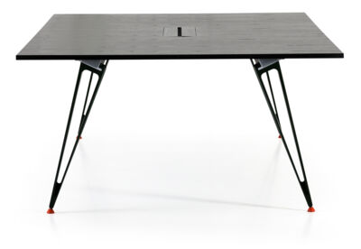

Replaceable parts | Tools needed
End caps | Knife
Glides | -
Legs | Allen key
Profiles | Screwdriver, assembly board (multiple tabletops)
Tabletop | Screwdriver, assembly board (multiple tabletops)

Instructions for replacement
End cap Use a knife or another thin tool to remove it. Push the new one in place.
Glides Remove the plastic part with your hand and klick on the new glide
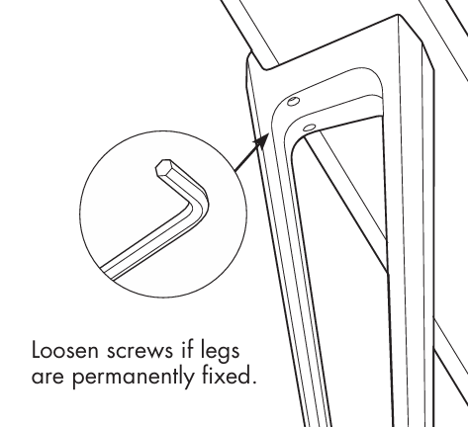
Leg Loosen the screws if the leg is permanently fixed. Pull the leg of the beam. Click on the new leg, make sure it’s in correct position.

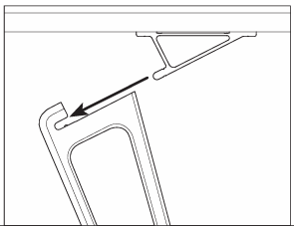

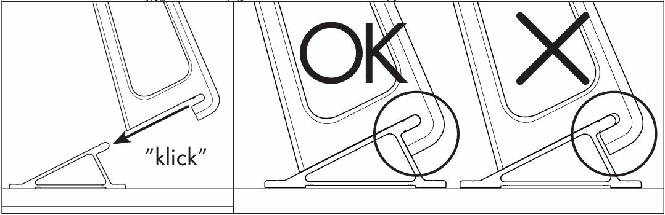

Profile Follow the Attach disassembly instruction to remove the profile. Then follow the Attach assembly instructions to assemble the new table. For tables with more than one tabletop, always use the assembly board.
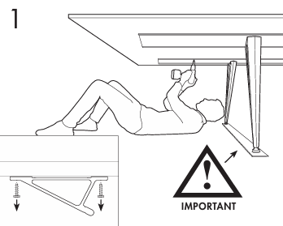

Tabletop Follow the Attach disassembly instruction to remove the tabletop. Then follow the Attach assembly instructions to assemble the new table. For tables with more than one tabletop, always use the assembly board.

Disassembly for recycling
Follow the separate disassembly instruction.

