DISASSEMBLY AND REPAIR
Product: ATLAS AIR

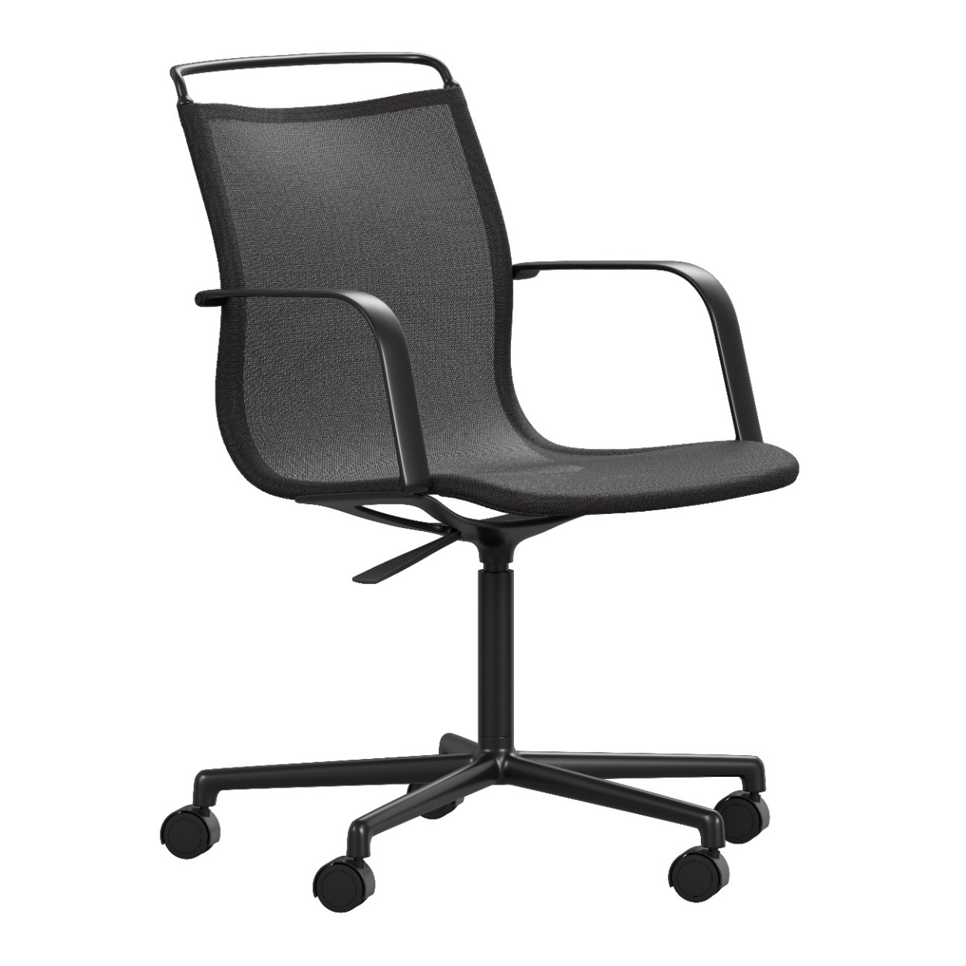

Replaceable parts | Tools needed
Armrests | Screwdriver
Seat/swivel base | Screwdriver
Seat attachment | Screwdriver
Starbase | Rubber mallet
Swivel column,  cover tube | Screwdriver, rubber mallet
Wheels/glides | -
Instructions for replacement
Armrests Loosen both screws and remove the armrest. Put the new armrest in place and reattach it with screws.
Seat/ Loosen all screws in the seat attachment and remove the swivel base. Replace the seat and
swivel base fasten the base (with armrests: add the steps above).
Seat Loosen all screws and remove the seat attachment. Ask a friend for assistance. One person
attachment takes a firm grip around the pillar while the other uses a rubber mallet to remove the seat attachment from the pillar by striking it. Place the new attachment on top of the pillar and push down firmly, with hands and body weight. Place the seat upside down with the entire base on top (with the height adjustment lever on the left side). Reattach the seat attachment with screws. Check that all parts are connected.
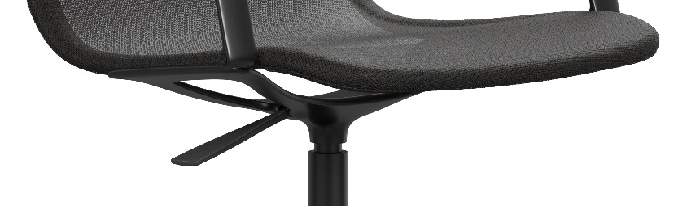

Starbase Ask a friend for assistance. One person takes a firm grip around the pillar while the other uses a rubber mallet to remove the starbase from the pillar by striking it. Detach the wheels/glides from the old base and fasten them on the new one. Place the chair on top of the new base and push down firmly, with hands and body weight. Check that all parts are connected.
Swivel Ask a friend for assistance. One person takes a firm grip around the seat while the other
column, uses a rubber mallet to remove the seat attachment from the pillar by striking it.
cover tube To switch the cover tube: Replace the cover tube. Put the swivel base on top and strike it with a rubber mallet. Check that all parts are connected.
To switch the swivel column: Repeat the first step but hold on to the pillar instead. Put the seat upside down. Place the column in the seat attachment with the smaller side upwards. Put the cover tube in place and the swivel base on top. strike it with a rubber mallet. Check that all parts are connected.
Wheels, Turn the chair upside down remove the glide or wheel out of the starbase by pulling it.
glides Replace it and push down firmly.
Disassembly for recycling
Loosen all screws with a screwdriver to remove the seat, backrest top and armrests. Use a knife or a pair of scissors to cut off the mesh fabric from the frame. Use a rubber mallet to disassembly the base. Remove the glides/wheels by pulling them.

