DISASSEMBLY AND REPAIR
Product: AREA & AREA RADIUS

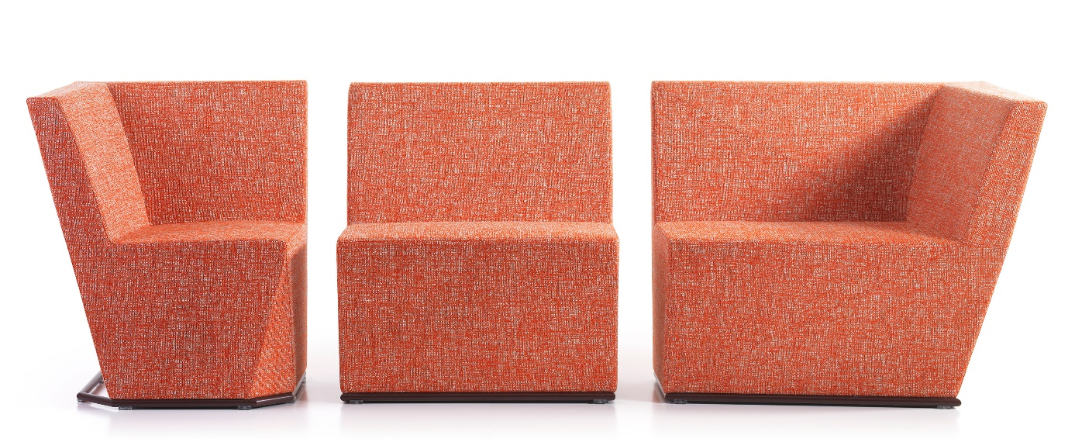

Replaceable parts | Tools needed
Base | Screwdriver

Instructions for replacement
Base Loosen the screws with a screwdriver to separate the base from the sofa. Put the new one in place and tighten the screws.

Disassembly for recycling
Turn the module upside down and remove the screws with a screwdriver to separatee the base from the frame. To remove the plastic glides, use a Ø5mm drill and drill out the pop rivets. Use a knife to remove the fabric. From the inside, remove the screws holding the magnets and remove them from the frame.

