DISASSEMBLY AND REPAIR
Product: ADD TABLE

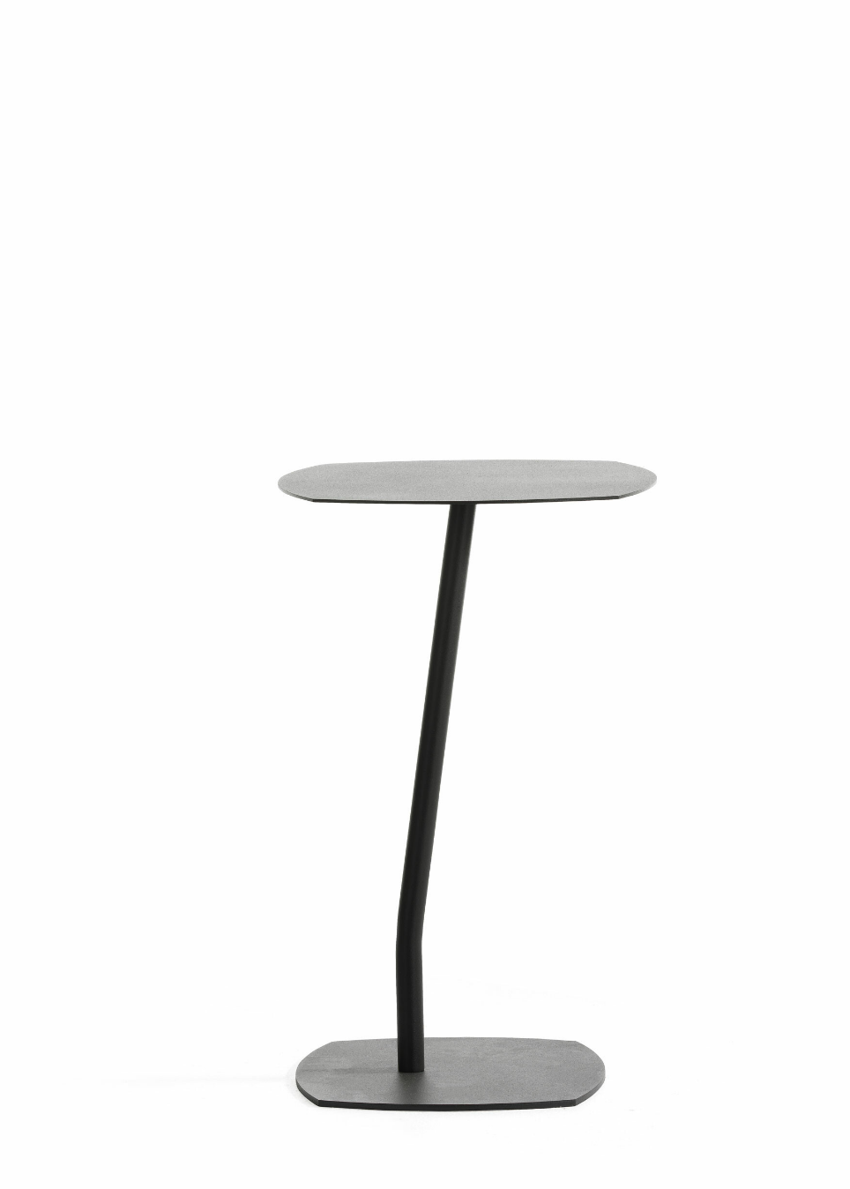

Replaceable parts | Tools needed
Foot plate | Screwdriver

Instructions for replacement
Foot plate Place the table upside down, protect the tabletop. Hold the foot plate in one hand and loosen the screws with a screwdriver. Replace the footplate, rotate it correct, insert the screws and tighten.
Felt Use a knife to remove the old felt. Remove the plastic on the backside of the new felt and carefully place it on the metal plate.
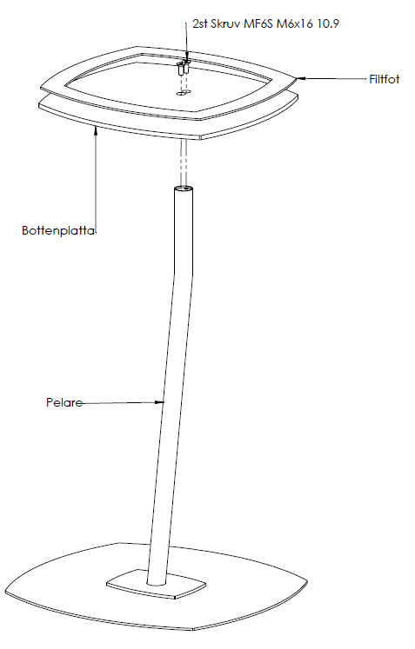

Disassembly for recycling
Loosen the screws at the bottom with a screwdriver to separate the base. Use a knife to remove the felt.

