DISASSEMBLY AND REPAIR
Product: ADD

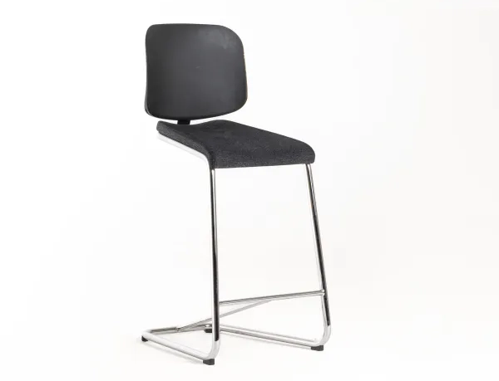

Replaceable parts | Tools needed
Backrest | Screwdriver
Seat | Screwdriver

Instructions for replacement
Seat Loosen all screws with a screwdriver and remove the backrest. Attach the new seat and reattach the backrest.
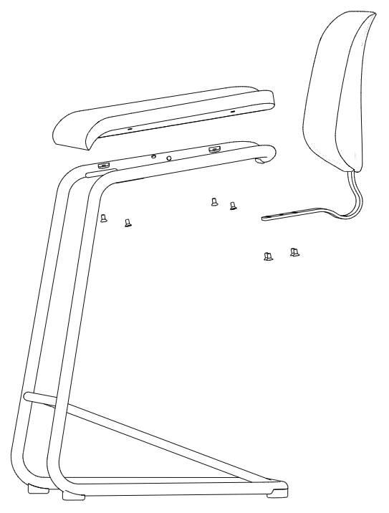

Backrest To be able to replace the backrest, you need to order a new, assembled backrest. Loosen the backrest screws with a screwdriver and replace the existing backrest with the new one. Recycle the old one by separating the parts, using a rubber mallet to strike the backrest.

Disassembly for recycling
Loosen all screws with a screwdriver to remove the seat and backrest. Use a rubber mallet to separate the backrest from the bracket. To remove the plastic glides, use a Ø5mm drill and drill out the pop rivets.

