DISASSEMBLY AND REPAIR
Product: A22

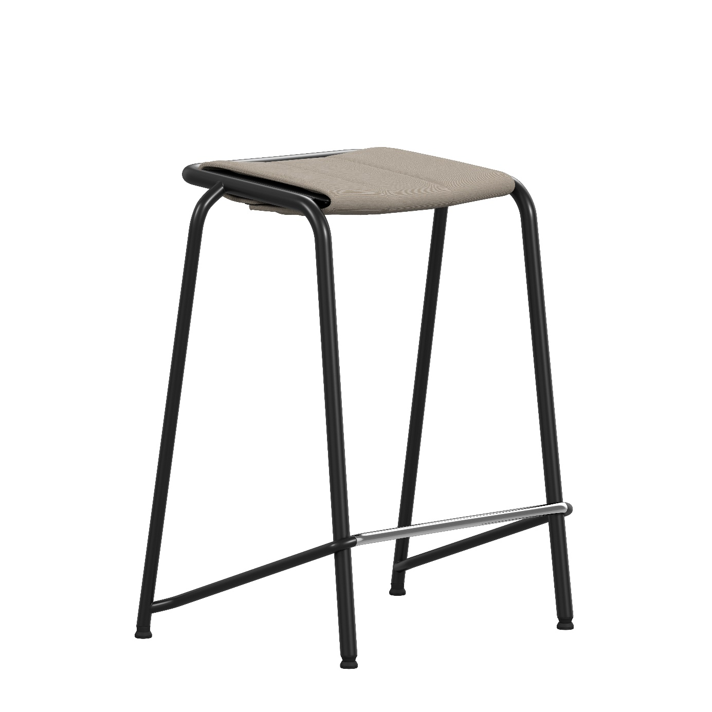

Replaceable parts | Tools needed
Glides | Adjustable pillars, rubber mallet
Seat pad | -
Instructions for replacement
Glides Remove the glide with adjustable pillars. Insert the new glide and tap with a rubber mallet.
Seat pad Separate the Velcro underneath the seat by hand. Attach the new seat pad.

Disassembly for recycling
Remove the glide with adjustable pillars. Remove the seatpad.

